**LAB TASKS**

**NAME: RAI AZMAT TARIQ**

**LMS ID: 465039**

**DATE: 4 OCT 2023**

**QUESTION :- 1**

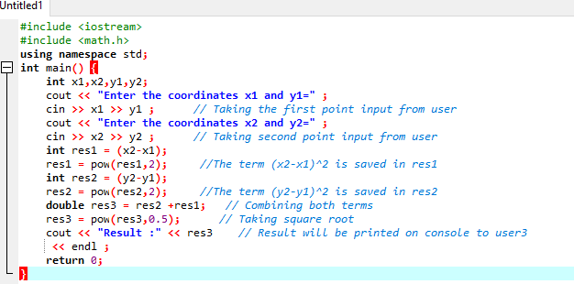

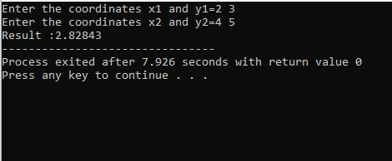

**QUESTION :- 2**

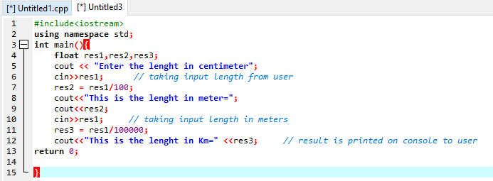

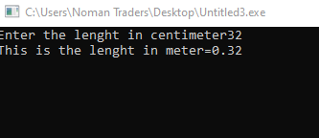

**QUESTION :- 3**

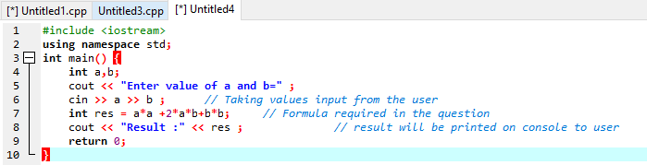

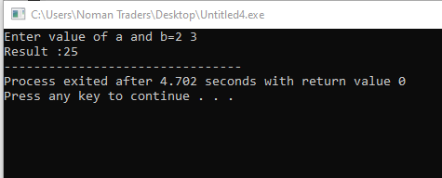

**QUESTION :- 4**

